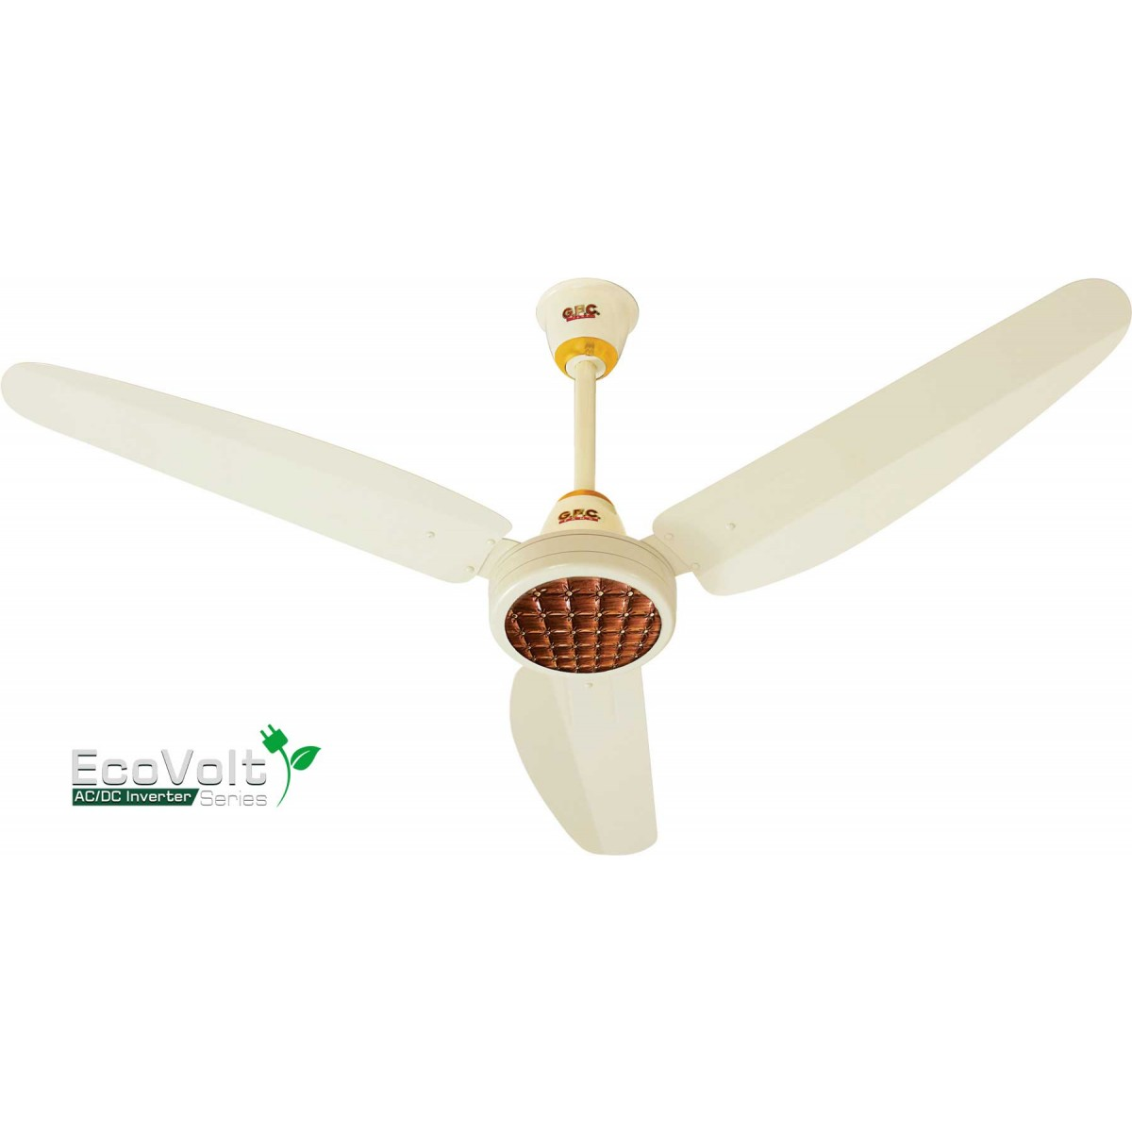

DW-5100

* Warranty Price In Pakistan
* 8 KG Capacity
* Single Tub
* Washer Only
* **Rs.25,500**